TranslationStudio for Android

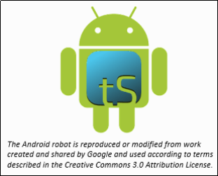

Table of Contents

Introduction to the translationStudio-Android Program 3

How do I install translationStudio on an Android device? 3

translationStudio-Android – Login Options 6

Which Type of Account Do I Want to Use? 6

Logging Out 11

How do I use translationStudio for the first time? 12

How do I select the target language? 13

How do I select what to work on? 15

How do I select or change the source text language? 16

How do I navigate in translationStudio? 18

Layout 18

Working Views Icons 18

Slider 20

Options Menu 22

How do I translate in translationStudio? 22

Create and Edit Text 23

How Do I Translate Footnotes? 28

Upload/Export Your Work 30

Recovering Deleted Translation Text 35

Publish Content 35

Self-Publishing 35

Source Text Publishing 35

Settings Window 38

General Settings 39

Server Settings 41

Legal Settings 41

**Advanced Settings** 42

Logging Level and Developer Tools 42

Find My Language 42

Backup and Share Your Work 43

MAST Core Concepts 43

Choosing What to Translate 44

What Should I Translate First? 44

Updating Program Elements 47

Updating List of Available Source Texts 47

Downloading Available Source Texts 48

Updating List of Available Target Languages 51

Checking for Updates to translationStudio 52

Find the Resources (Helps) in translationStudio 52

## [Introduction to the translationStudio-Android Program](http://help.door43.org/en/knowledgebase/9-translationstudio/docs/10-introduction-to-the-translationstudio-android-program)

The translationStudio-Android is a mobile app where translators can do offline translating. It can be downloaded for Android devices: see <https://play.google.com/store/apps/details?id=com.translationstudio.androidapp&hl=en>.

It contains the content that needs to be translated as well as translationHelps (See: How to Use the translationHelps in translationStudio). You can share information directly from device to device, and you can upload finished content to Door43 where it can be digitally published.

## How do I install translationStudio on an Android device?

**Note:** This process requires an Internet connection.

1. Tap the **Google Play Store** icon on the Android device. Google Play Store opens.  
   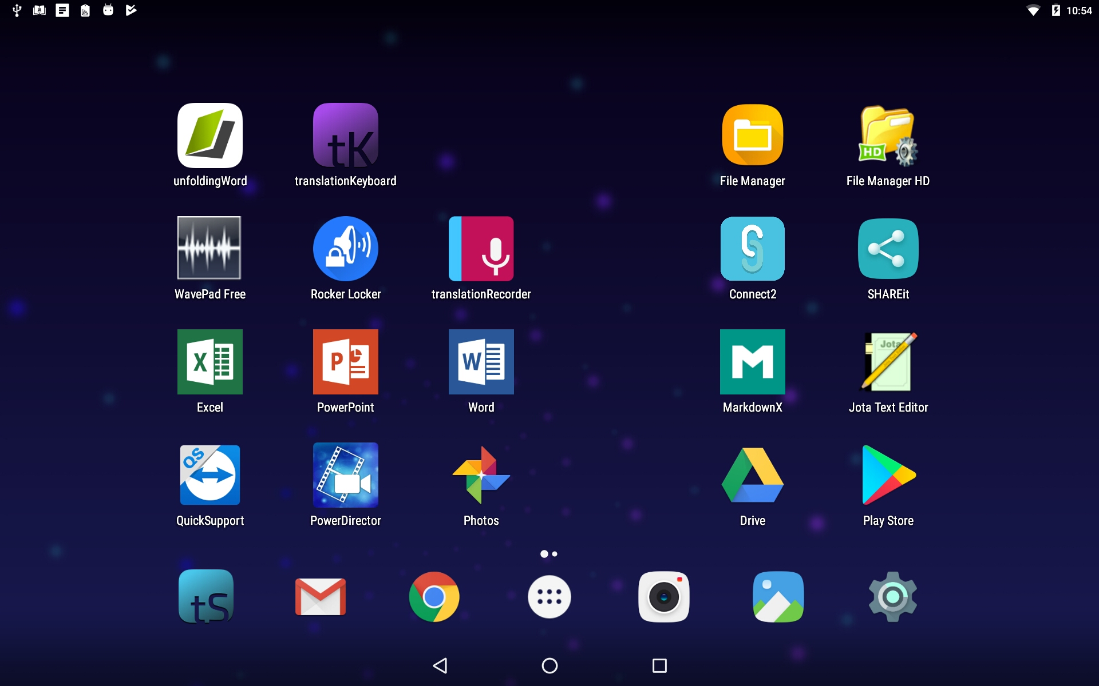
2. In the search bar at the top of the screen, type **translationStudio** with no spaces and tap the magnifying glass  on the keyboard.  
   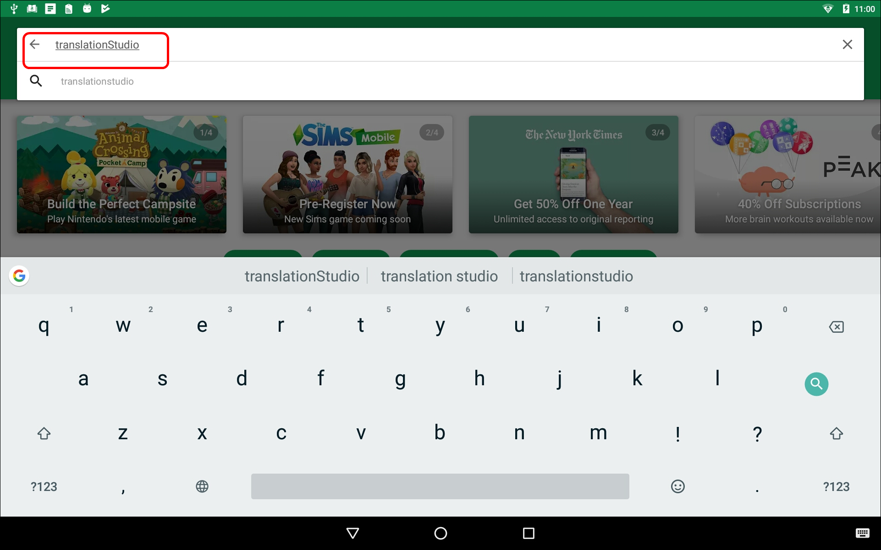
3. When the Play Store has found the program, tap the **tS** icon.  
   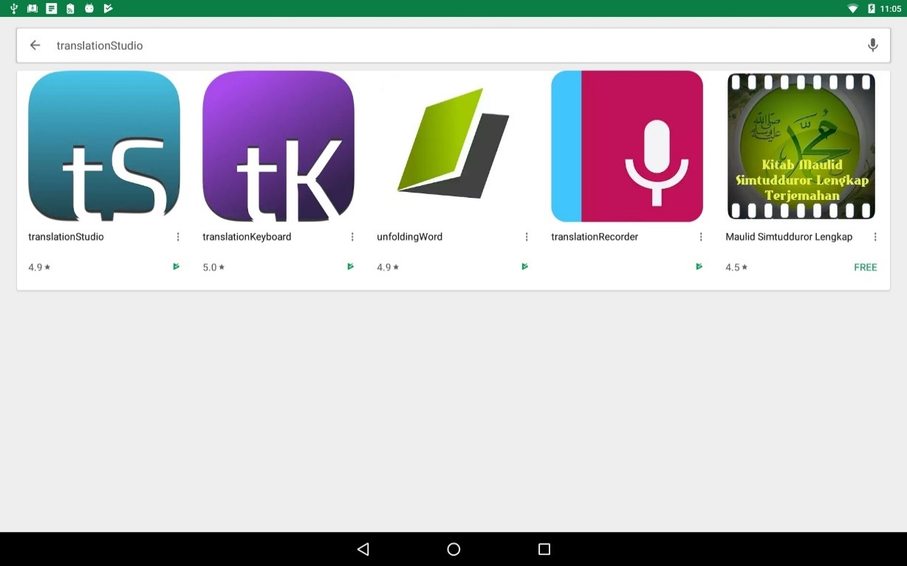
4. Tap **Install** . The program downloads and then installs.  
   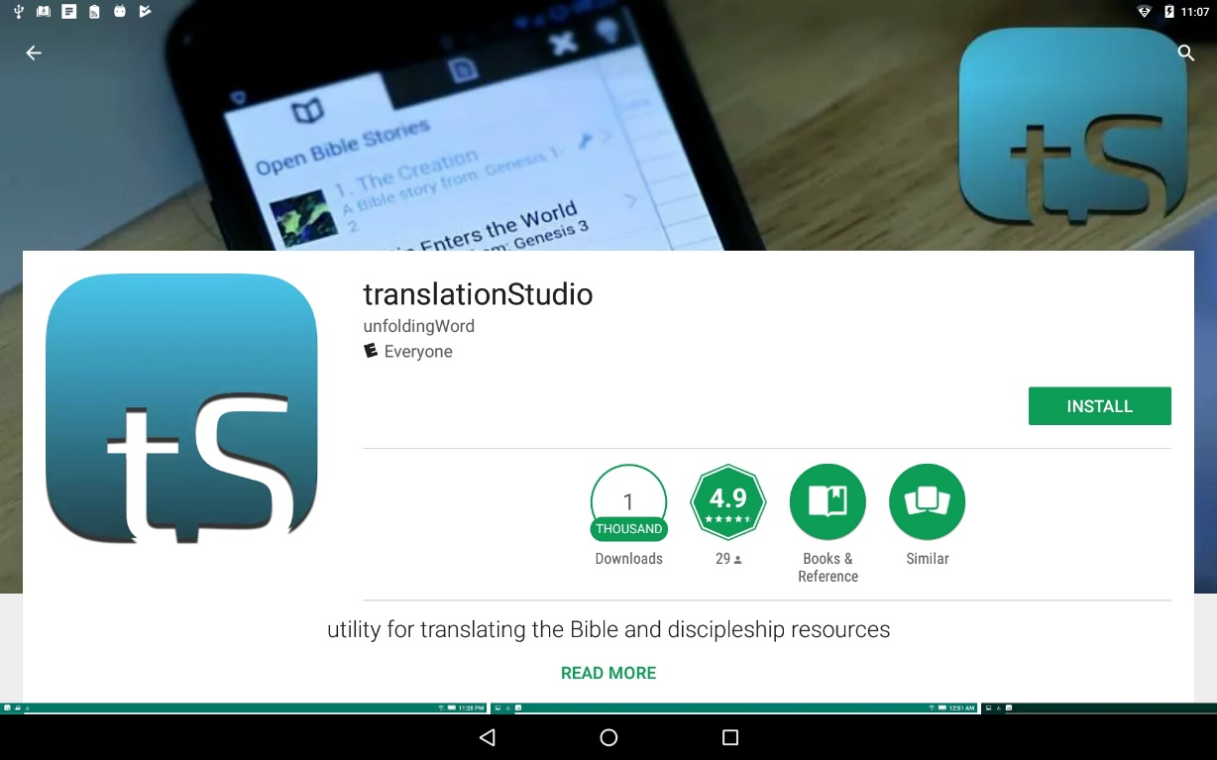
5. Once the program is installed, tap **Open**.  
   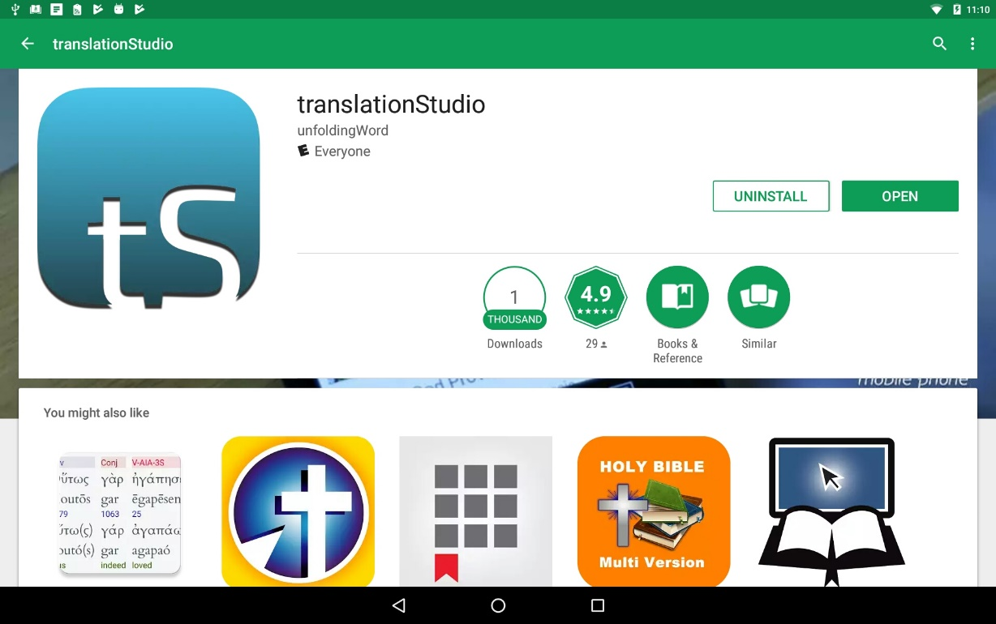
6. Tap **ALLOW** to enable translationStudio to access photos, media, and files on your device.  
   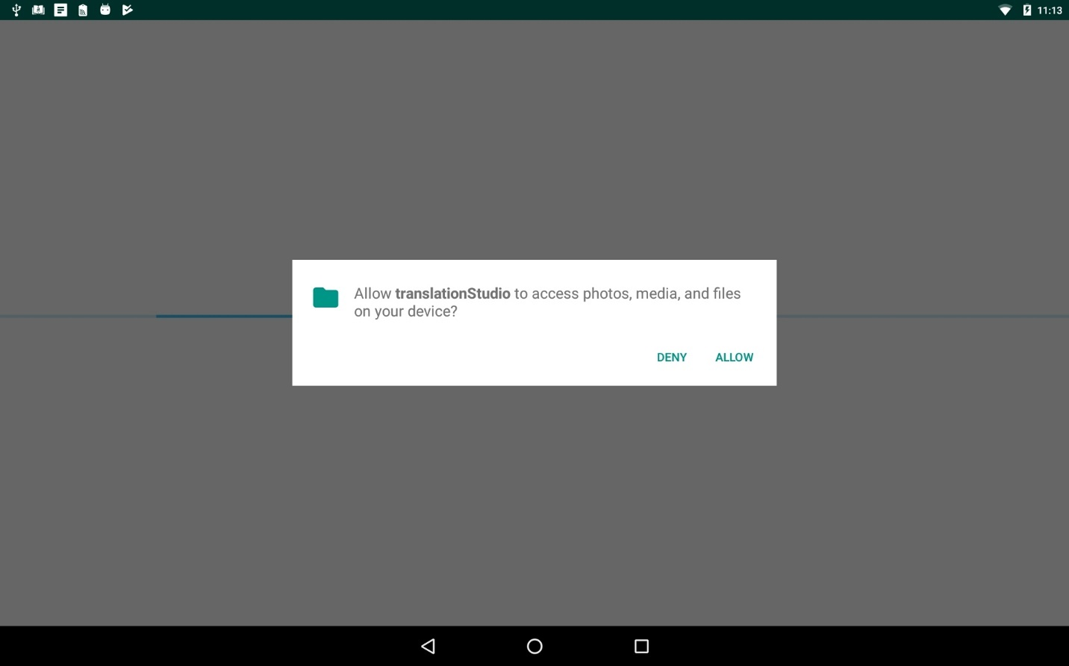  
     
   There may be an automatic update before the translationStudio app opens.

## translationStudio-Android – Login Options

The welcome screen displays a request to create or log in to a user account.  
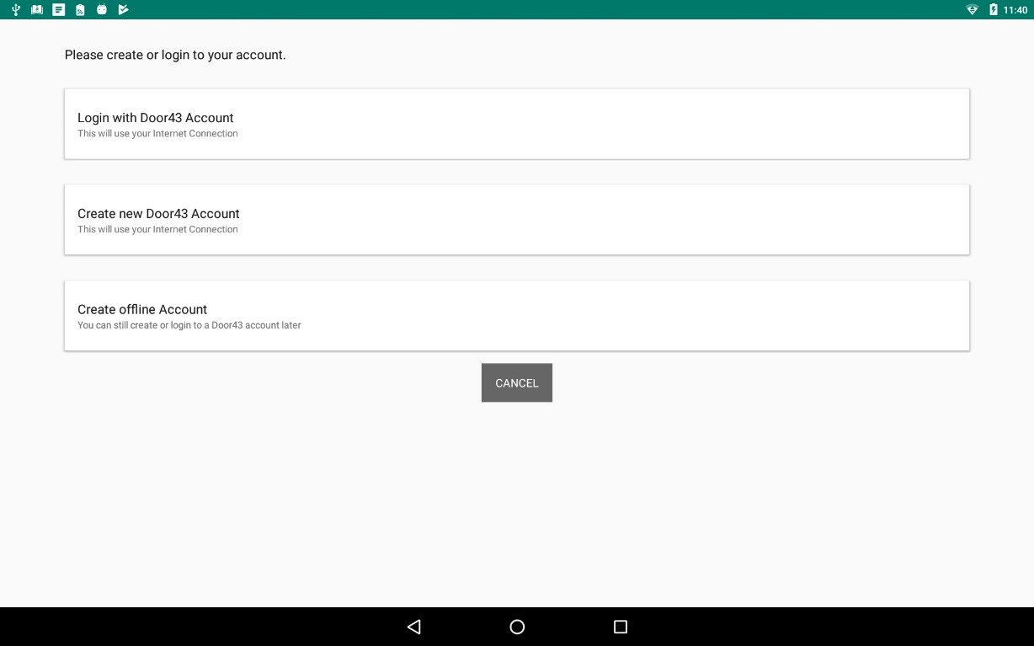

**NOTE:** You may use a pseudonym instead of your real name. A pseudonym is a name that cannot be traced back to you.

### **Which Type of Account Do I Want to Use?**

**Offline Account** – user has full use of the program except for uploading to Door43. You may want to start with an offline account and then switch to a Door43 account later when you want to upload your work (the work is attached to the device, not to the account). If you want to use an offline account, skip to the Local Login or Offline Account section.

**Door43 Account** – user has full use of the program and can upload to Door43 (requires Internet connection.)

#### **Existing** Door43 Account

If you already have a Door43 account, you can log in with it. If not, skip to the New Door43 Account section.

1. On the opening screen, tap **Login with Door43 Account**.   
     
   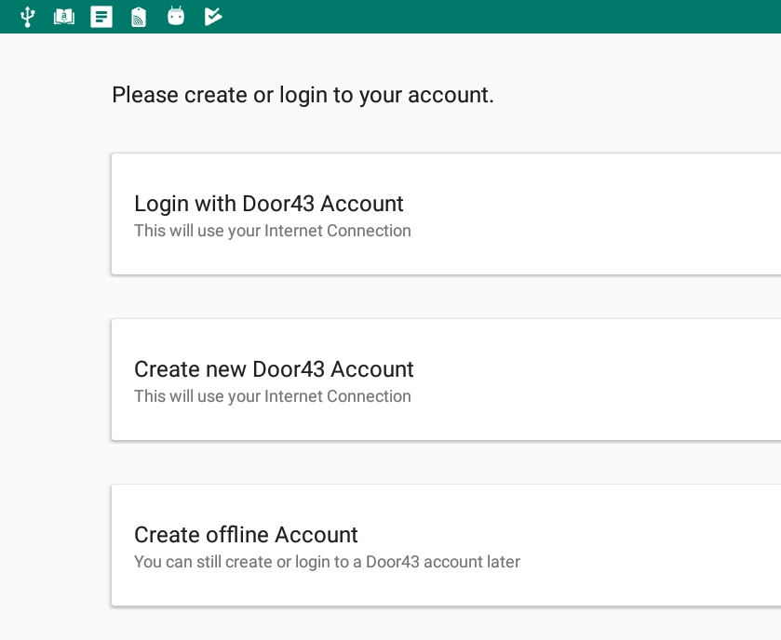
2. The login screen opens. Type in your Door43 account information and tap **Continue**.  
   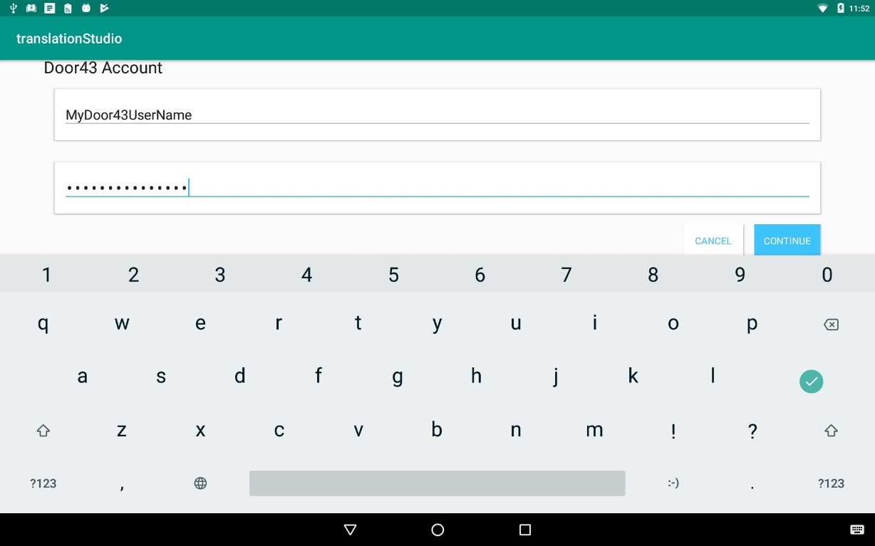
3. Skip to the How do I use translationStudio for the first time section.

#### New Door43 Account

If you do not have a Door43 account, but you wish to be able to use an Internet connection to upload your work to Door43, you can create a Door43 account.

1. On the opening screen, tap **Create new Door43 Account** to create a new Door43 user account. The Door43 Account Creation window opens. (This requires an Internet connection.)  
   
2. Tap the **Your Name or Pseudonym** field and type your user name or pseudonym into the field. This is the display name -- the name that will be listed as a contributor to any project files on this device.  
   **Note**: Because names are publicly available, you may prefer to use a pseudonym. Make up any pseudonym of your choice.  
   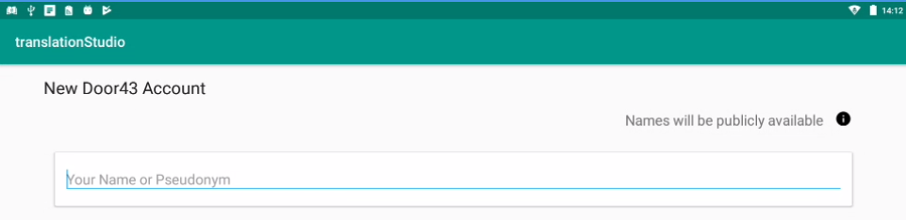  
     
   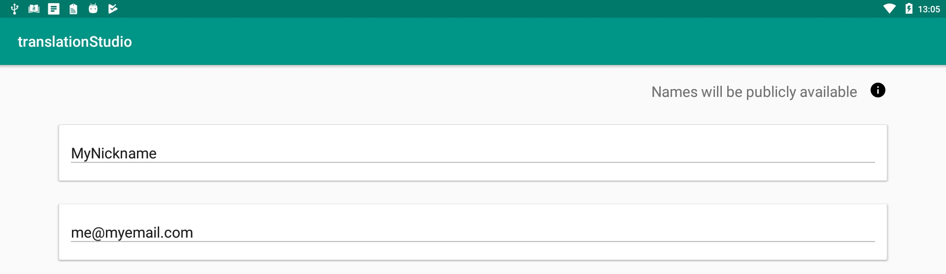
3. Tap the 'Email Address' line to enter your email address.  
   
4. Enter your name or pseudonym in the **Login name** field. This is your Door43 user name that you will use to log in to Door43 and to the translationStudio app. If you used a pseudonym in step (2) above, enter the same pseudonym here.  
   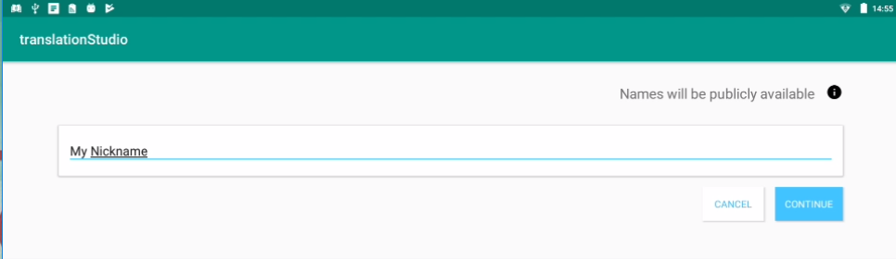
5. Enter a password in both fields. Tap **Show Passwords** at the bottom of the screen to display the passwords.  
   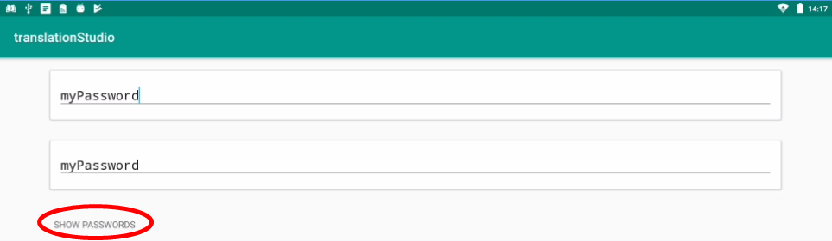
6. Confirm the information, and then tap **Continue** to begin registration.  
   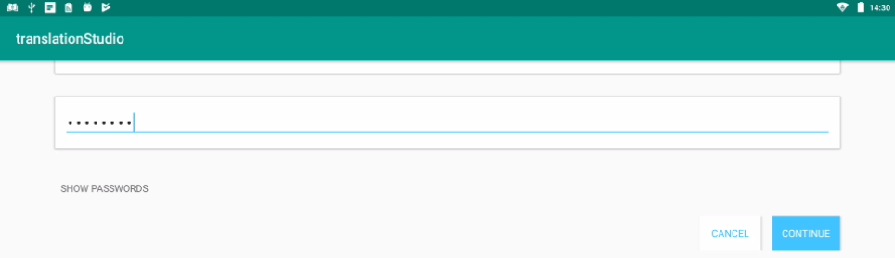
7. Tap **Continue** to acknowledge the privacy notice.  
   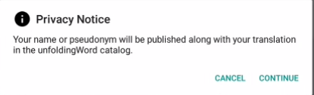
8. Skip to the How do I use translationStudio for the first time section.

#### Local Login or Offline Account

If you do not want to create a new Door43 account at this time or are not able to connect to the Internet., you can create an offline account.

1. On the opening screen, tap **Create offline Account**. The login screen opens.  
     
   
2. Tap the **Your Name or Pseudonym** field. 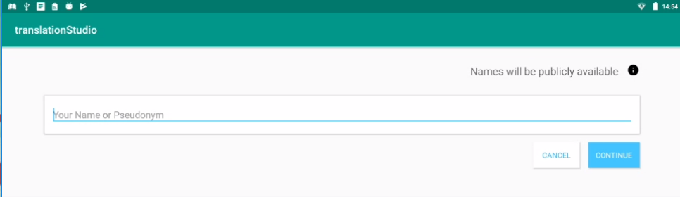
3. Type your user name or pseudonym into the field, and then tap **Continue**.

**NOTE:** You may use a pseudonym instead of your real name. A pseudonym is a name that cannot be traced back to you.

1.   
   
2. Tap **Continue** to acknowledge the privacy notice.  
   

### **Logging Out**

**You do not need to log out of the app before you close it. If you do not log out, when you reopen translationStudio you will still be logged in.**

**However, you may want to log out to change the logged-in user. For example, you may do your work offline with an offline account, but when you want to upload your work you need to use a Door43 account.**

**At any time you can perform the following steps to access the initial screen to change login or translator settings:**

* From the *Your Translation Projects* screen:
  + Tap the 3-dot icon  to invoke the options menu. This icon is at the lower left if your tablet is held horizontally, or at the lower right if the tablet is held vertically.
  + Tap **Log out.**

OR

* Tap **Logout** at the top right of the screen next to the user name.  
    
  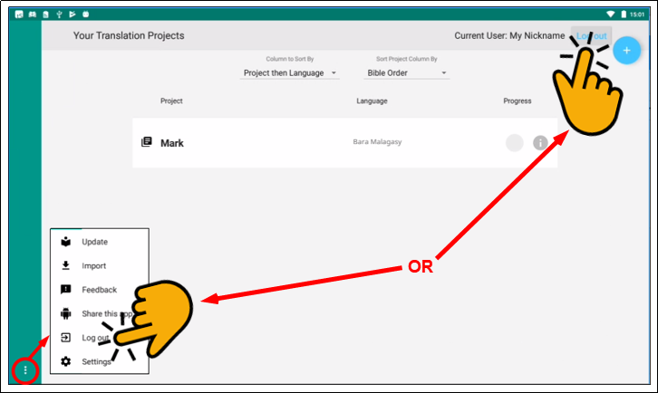

## How do I use translationStudio for the first time?

Complete these steps to use translationStudio for the first time:

1. If translationStudio is open, skip to step 3. If it is not open, tap the **translationStudio icon** 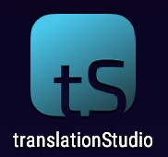 on the tablet (this icon may not be on the main screen; you may need to scroll to a different screen to find it.)

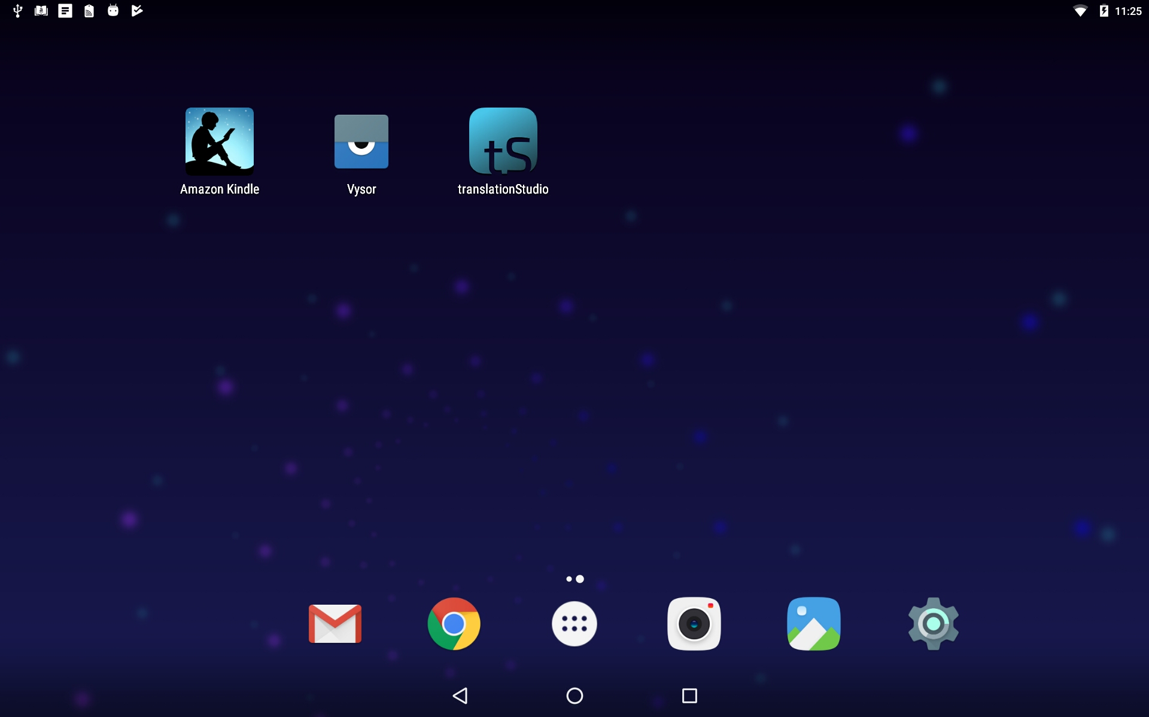

1. Create or login to your account. See translationStudio-Android - Login Options for more information.
2. Read and agree with each of the statements in the Terms of Use by performing the following steps:
   1. Tap each statement.
   2. Scroll through the text to read the entire statement.
   3. Tap **Close** for each statement.
   4. When you have read all statements, tap **I Agree**.

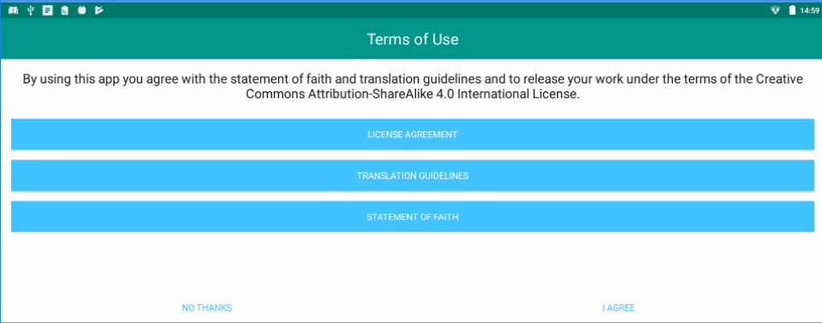

**Note:** At any time you can view the License Agreement, Statement of Faith, Translation Guidelines and the Software Licenses information from the Settings Menu. (See: Settings Window)

1. The program opens to the *Your Translation Projects* screen (which is the home screen). The first time you use the program you have no existing projects, so the home screen displays a welcome message. Tap the **plus icon**  in the upper right ***or*** the **Start a New Translation** button at the bottom to start a new project.  
     
   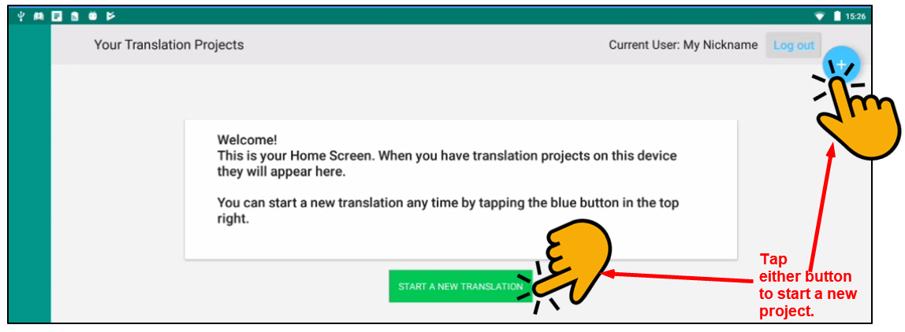

A translation project consists of:

* A target language - the language into which you will be translating
* A project category - what you will be translating, such as Open Bible Stories or a book of the Bible
* A source language and text - the language and text you will be translating, such as the English ULB (Unlocked Literal Bible)

So, to start a translation project, you must specify each of these elements.

### How do I select the target language?

When you start a new project, you need to choose the target language (the mother tongue language *into* which you will be translating).

1. Choose your target language (the one you will be translating *to*):
   1. Swipe up (place a finger on the white area and slide up) to find the target language    
        
      **OR**
   2. Tap the magnifying glass icon  located at the top right of the screen.   
      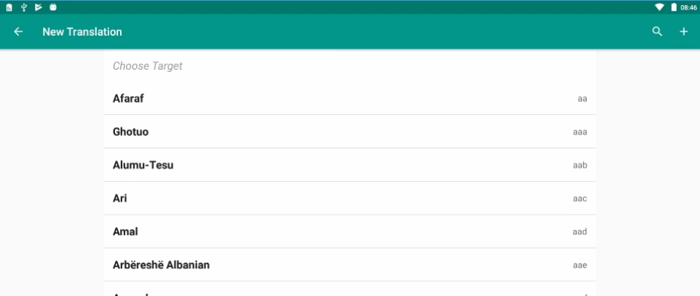
      * The search field opens and the keyboard appears.
      * Type the first few letters of your language to narrow the language list.   
        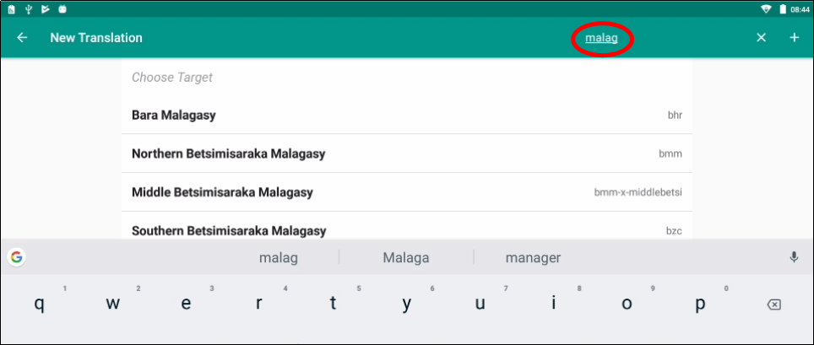
   3. Tap your language to select it.  
      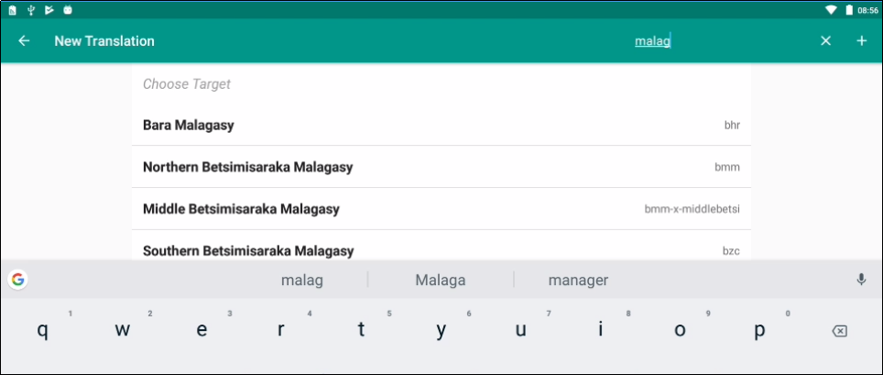

What if you cannot find the desired target language? Then see Find My Language for information on searching and requesting a new language.

#### Can I change the target language of an existing project?

If you make a mistake and designate the wrong target language, after you have finished defining the project, you can change the target language.

On the Home page, tap the  icon next to the project whose target language you wish to change.

On the information window, tap **Change** next to the target language.  
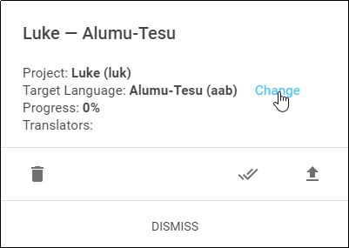

The *Choose target language* window appears, enabling you to select a different target language. As soon as you select a language, a message displays to tell you the change is complete.

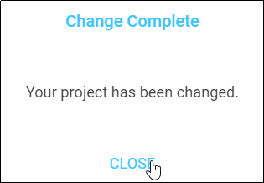

Tap **CLOSE** to dismiss the message.

### How do I select what to work on?

We recommend that you begin by translating Open Bible Stories. You can work your way through the Stories however you want, but we have found that Story #31 (see <https://door43.org/en/obs/31>) is a good first story to translate since it is short and easy to understand. For more information read Choosing What to Translate.

To designate what to work on for this project, complete the following steps:

1. Choose a project from the *Bible: OT*, *Bible: NT*, or *Open Bible Stories* to start translating.  
     
   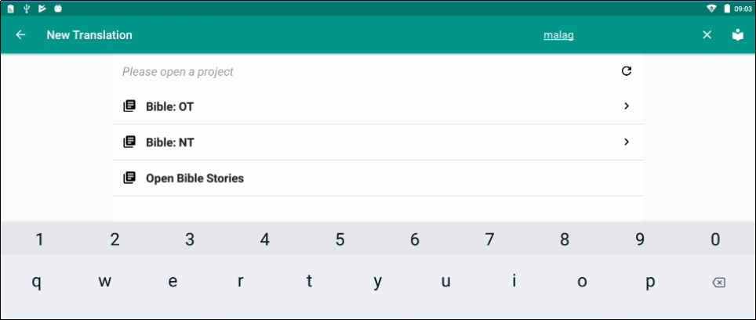
2. If you choose either the Old or New Testament, you next choose a book for the project.  
   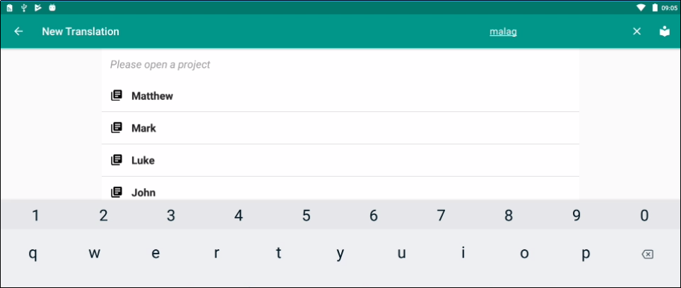
3. The new translation project opens showing the Chapter or Story view. If you choose an *Open Bible Stories* project, it opens to the first paragraph of The Creation

### How do I select or change the source text language?

You can select and/or change your source text language whenever you use translationStudio.When first creating a new project, you must select a source text language. This is the text you will be translating *from*.

In the translation project complete the following steps to select or change the source text language:

* Tap the rectangular icon with the + and - sign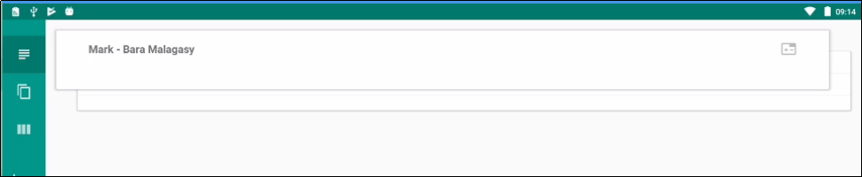 found at the top right of the source text window.  
  
* Tap the empty square box next to the desired source text and language. You can scroll down to see additional languages, or search by using the magnifying glass icon at the upper right of the *Choose source translations* box.  
  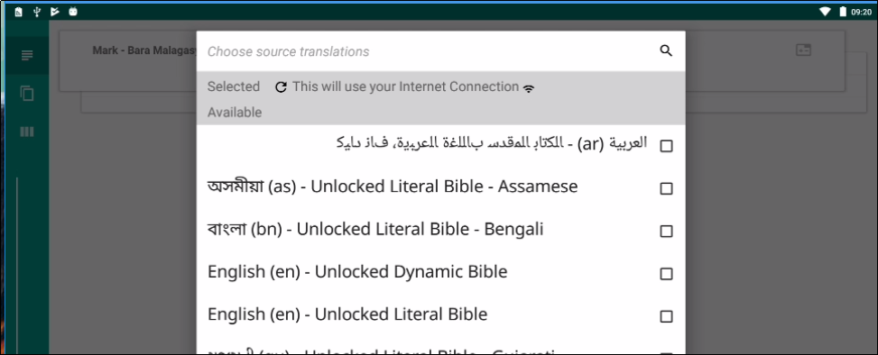  
   **Note**: You can choose multiple source texts; those selected are moved to the top portion of the *Choose source translations* box under the *Selected* heading.
  + Choosing multiple source texts enables you to compare them as you are performing the translation work.
  + For example, when translating the you should always choose the Unlocked Literal Bible (ULB) as a source, but you may want to also choose the Unlocked Dynamic Bible (UDB) if it is available in your language because it may be easier to understand. Looking at the UDB may help you to translate or check a passage.

To save the selection(s), tap **Confirm** at the bottom right of the *Choose source translations* box, OR tap **Cancel** to close without saving the selected language.   
**Note**: You are not able to work in a project until you choose a source text language.  
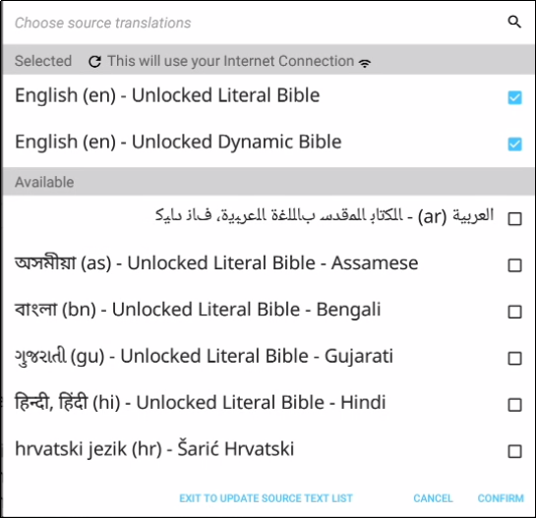

## How do I navigate in translationStudio?

### Layout

There are two screens in the translationStudio app:

* The Home screen, or *Your Translation Projects* screen, shows any projects that have been created on the tablet. If there are no projects, the Home screen displays a welcome message. The Home screen also shows the user name and a Log out button.
* The *Project* screen shows the source and target texts, and can also display translationHelps.

The *Project* screen is where you perform all of the translation work on a single project. It shows the source text and the translated text. The *Project* screen can display three different views of these and contains navigation and menu icons to enable you to move around in the program.

The navigation and menu icons are on the left of the screen if you hold the tablet or phone in a horizontal position, and at the bottom of the screen if you hold the device in a vertical (tall) position.  **It is best to hold the tablet or phone in a horizontal position.**

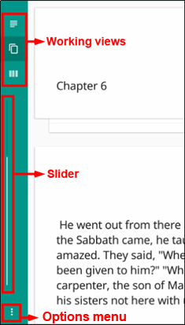

In the horizontal position:

* The top three icons are the working views.
* The slider in the middle moves through the text.
* The options menu is the three dots icon at the bottom.

### Working Views Icons

The **Chapter or Story** icon  is the top working views icon on the left (held horizontally) or bottom left (held vertically) and looks like 3½ horizontal lines.

* Swipe up to read the entire chapter or story in the source text language.
* Swipe to either side, or tap the page behind the text, for a blank page to enter the target language translation of the text. (See: Create and Edit Text for more information.)  
  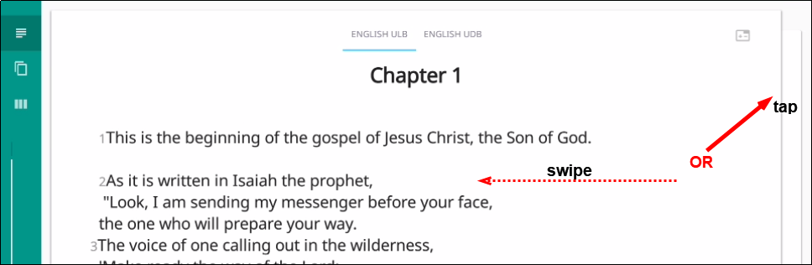

The **Chunk** icon  is the middle working views icon on the left (held horizontally) or bottom (held vertically) and looks like two pages, one behind the other. This shows the text divided into chunks, or small sections of the story or chapter.

Swipe down or up to move from chunk to chunk. Swipe to the side, or tap the page behind the chunk, for a blank page to type in the target language translation of the text.  
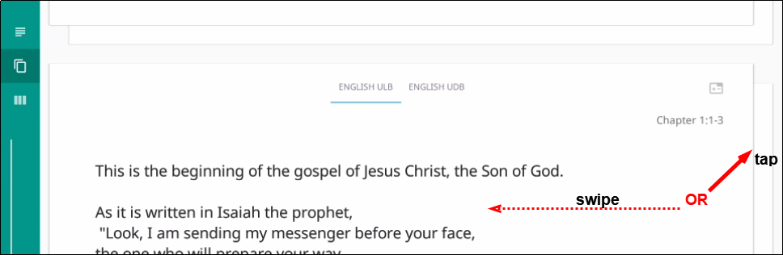

The **Check** icon 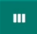 is the last working views icon on the left (held horizontally) or bottom (held vertically) and looks like three vertical lines. In this view the source text is on the left and the translation work is on the right.

Swipe up or down to move from chunk to chunk. Swipe from the right to the left side, or tap in the right margin, to show the resources for that chunk. (See: Find the Resources (Helps) in translationStudio for more information.)   
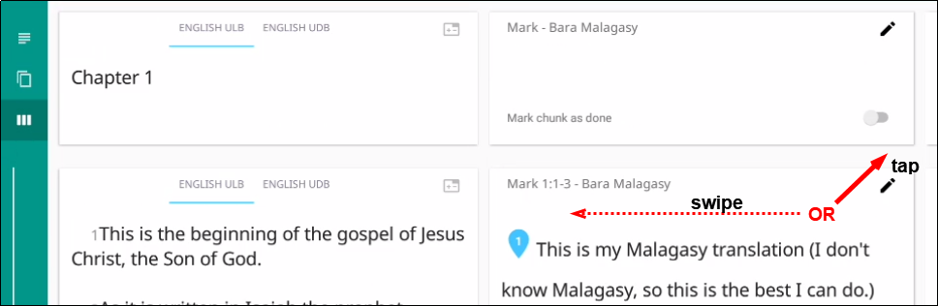  
  
The **Resources pane** is divided into three tabs. All of the **translationNotes**, **translationWords**, and **translationQuestions** are included in translationStudio. See Find the Resources (translationHelps) in translationStudio for more information. Tap either **Notes**, **Words**, or **Questions** to navigate among the tabs. If there are no existing resources for a particular chunk, the resources pane is blank. If there are no resources of one of the types (such as Words), then that tab does not exist on the resources pane (you would see only the Notes and Questions tabs).  
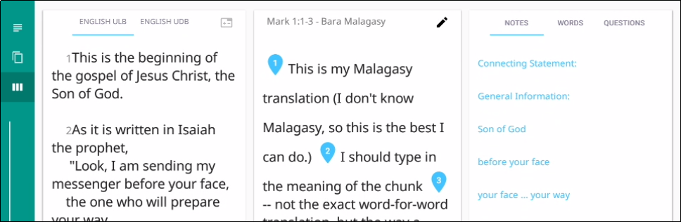

### Slider

The **Slider** icon is a quick way to move through a story or book of the Bible. Tap-and-hold the slider and drag it towards the bottom (right) or the top (left) of the slider. Numbers may appear on the line that represent the chapter of the book at that location of the slider.  
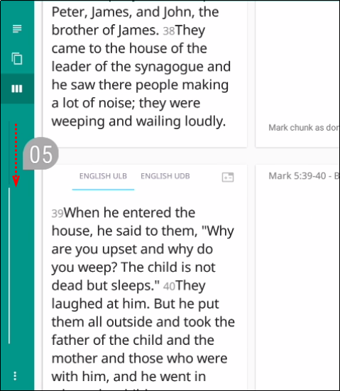

### Options Menu

Tap the **three dots icon**  at the bottom left (or right) of the screen to open the options menu. The Project screen and the *Your Translation Projects* screen (home screen) have two different menus.

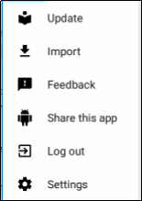On the *Your Translation Projects* screen the options menu includes the following options:

* Update
* Import
* Feedback (See: <http://help.door43.org/en/knowledgebase/9-translationstudio/docs/29-report-problems-and-making-suggestions>)
* Share this app
* Log Out
* Settings (See Settings Window)

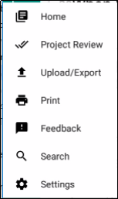  
On the Project screen the options menu includes:

* Home - returns to the *Your Translation Projects* screen   
  (home screen)
* Project Review
* Upload/Export
* Print
* Feedback (See <http://help.door43.org/en/knowledgebase/9-translationstudio/docs/29-report-problems-and-making-suggestions>)
* Settings (See Settings Window)

## How do I translate in translationStudio?

A basic translation process for any unfoldingWord project is explained here.

As you translate, be sure that you:

* Pray that God would help you make an easily-understandable, Scripturally-accurate translation
* Translate everything that is in the source text language.
* Do not add anything that that is not necessary for comprehension.
* Always do your translation according to the Translation Guidelines (see <https://unfoldingword.org/guidelines/>).
* Always do your translation according to the Statement of Faith (see <https://unfoldingword.org/faith/>).
* Use the translationNotes (see [https://unfoldingword.org/tn/](https://unfoldingword.org/tn/ )for OBS and  [https://unfoldingword.org/tn/](https://unfoldingword.org/tn/ )for the Bible) and the translationWords (see [https://unfoldingword.org/tw/](https://unfoldingword.org/tw/ )) to help you make a better translation (these resources are also available within translationStudio (see Find the Resources (Helps) in translationStudio).

### Create and Edit Text

#### Translate Text

To write the translation in your language:

1. Go to the story or book that is being translated.
2. The screen is arranged to appear like two sheets of paper, one behind the other, with the **Chapter or Story** view initially on top. In this view, read the source text.
   1. The app is organized to work with blind drafting.
   2. You may want to read MAST Core Concepts to understand the steps of blind drafting translation.
3. When you are ready to begin translating, tap the “piece of paper” that is behind the one you have been reading.  
   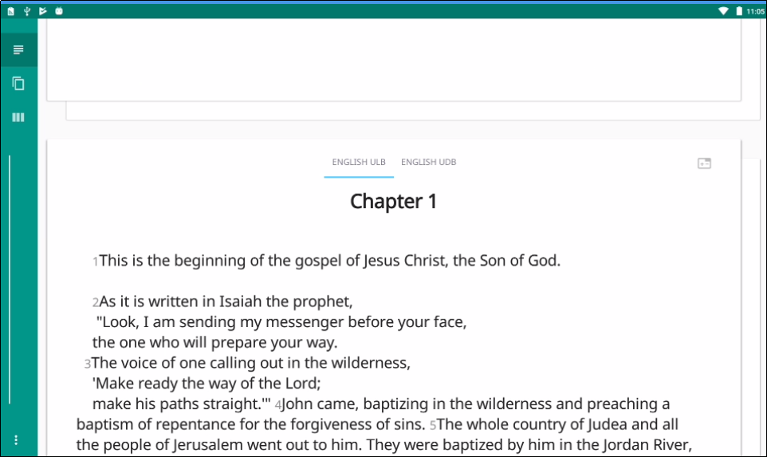
4. Tap the **Begin Translating** icon.   
   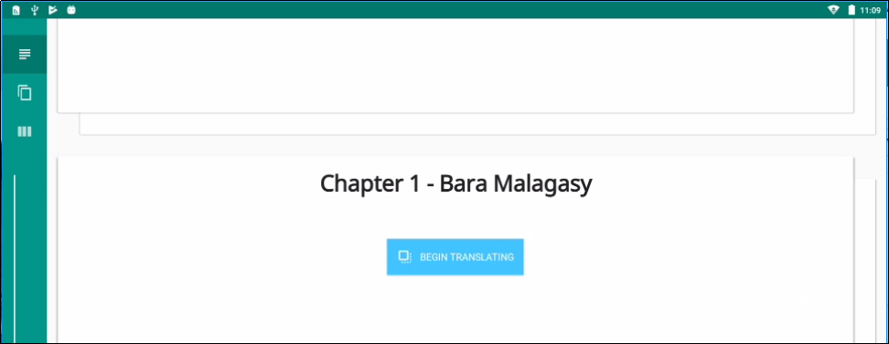
5. The **Chunk** view appears and displays the text divided into chunks, which are sections that you should be able to retell without looking. Read a chunk over until you can remember what it says.
6. Tap the blank paper behind the one containing the text.   
   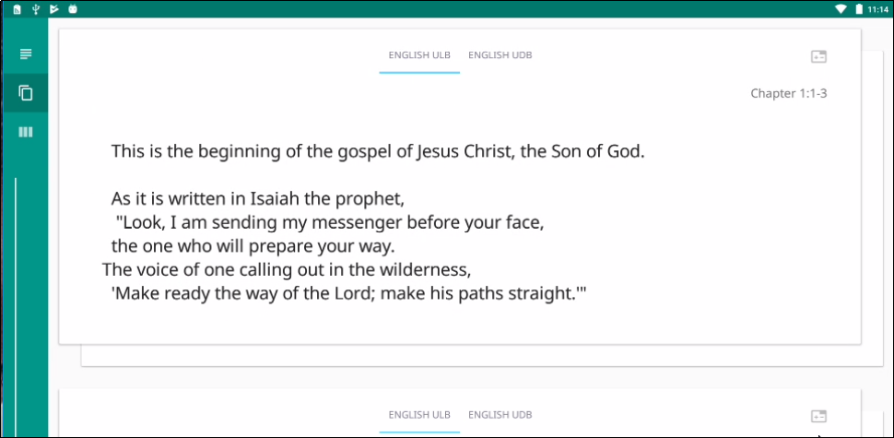
7. Tap anywhere on the blank sheet of paper to open a keyboard to begin working.   
   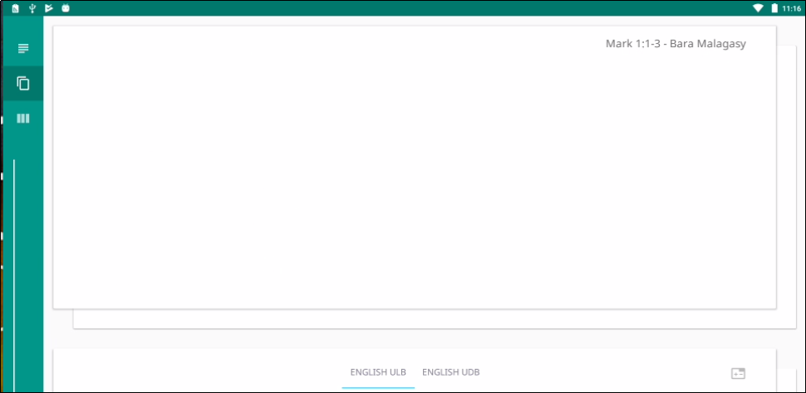
8. Type in the translation for that chunk on the page. This should not be a word-for-word translation, but it should be expressed in a way that would sound natural to a native speaker of the language.  
   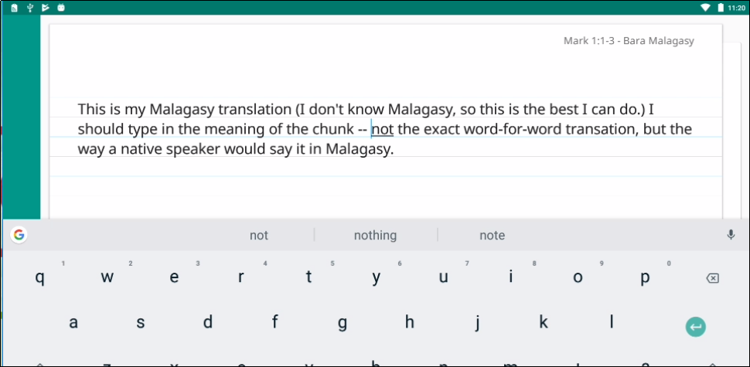  
   1. Start translating with a blind draft. Set aside the source text and draft the chunk as well as you can without looking back at the text.
   2. Write everything that you remember about that chunk.
   3. Do not look back at the source text for this chunk until you begin the editing steps.
9. When you are finished working, swipe up to work on the next chunk.  
   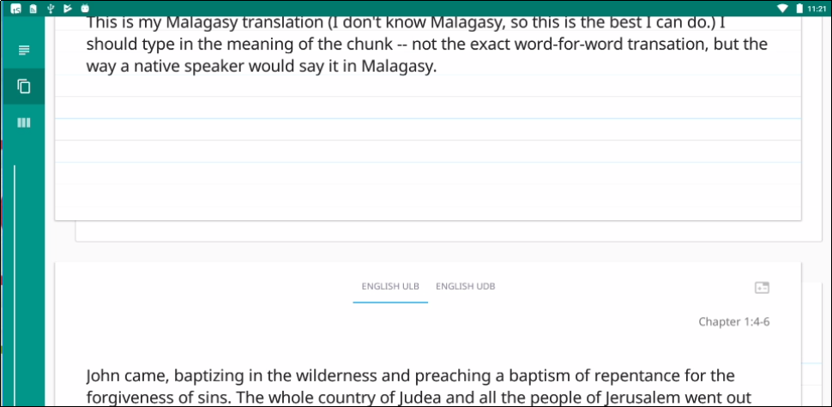
10. Continue doing this with each chunk of the chapter before moving to the checking steps.

#### Check and Edit Translated Text

When you use translationStudio, you can create and change text. Use the **Check**view to edit existing work that you or another translator created. Your work is saved automatically every five minutes.

To enter the Check view, tap the **Check View icon**  at the left or bottom of the page.  
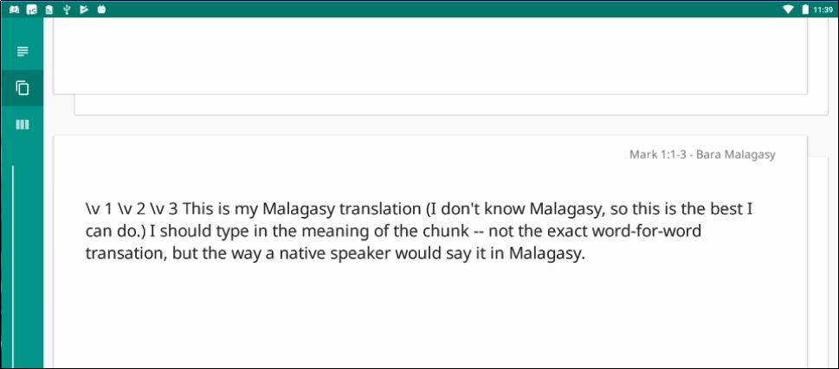

In the Check view the source text is on the left and the translation work is on the right. You can compare the two and then edit the translation to include all details in the source text.

In the Check view you can access all of the translationNotes, translationWords and translationQuestions that have been included in the program. See Find the Resources (translationHelps) in translationStudio for more information.

If you need to make changes in the translated text, perform the following steps:

1. Tap the **pencil icon**  at the top right of the translated chunk.   
   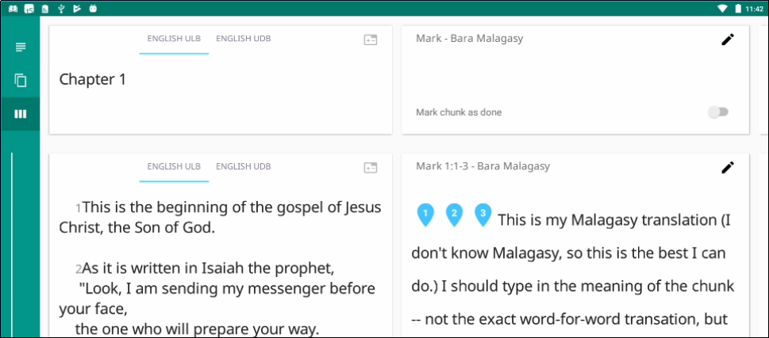
2. The keyboard appears. Edit the text to include all details and correct any grammatical or spelling errors.  
   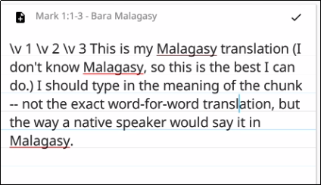
3. Tap the check mark icon  when done editing. The keyboard disappears.  
   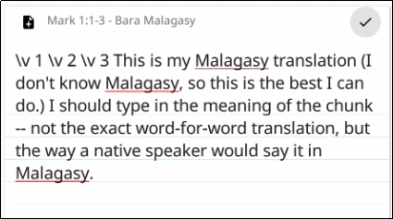
4. Place the verse markers (skip this step if you are translating Open Bible Stories, which are not divided into verses).
   1. There is a verse marker for each verse in the chunk.
   2. Tap and hold each verse marker and drag it to the beginning of each verse, dropping it above and slightly to the left of the location where it should go.  
      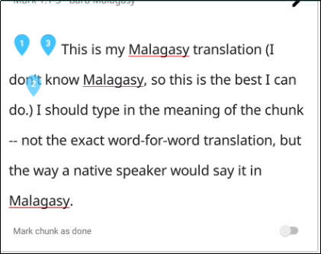 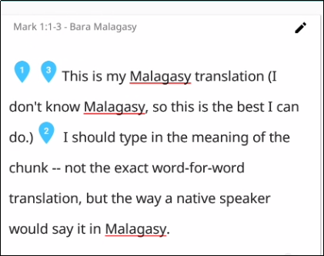
   3. Continue until all verses are marked with a verse number.
5. When you are finished working, use the toggle  at the bottom of the chunk to mark the translation of that chunk done. Slide the toggle to the right, or just tap it, to indicate that the chunk is finished.  
   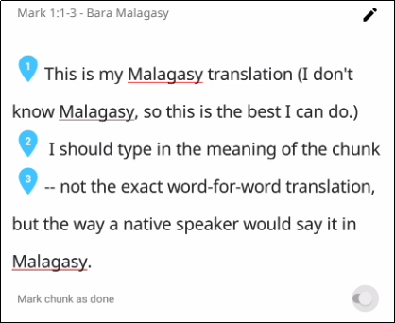  
   1. A message appears for you to confirm that the chunk is done. Tap **Confirm** to indicate that the work is done, or tap **Cancel** to continue editing.  
      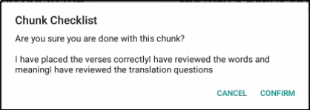

At any time you can slide the toggle  back to the left, or just tap it, to edit the chunk again. Use the above steps to edit.

## How Do I Translate Footnotes?

A footnote is additional text that usually appears at the bottom of a book’s page and is referenced within the page.

In translationStudio, a footnote is shown as a black page icon that you tap to display the footnote.

Footnotes can provide further explanation when:

* There are proper names, words or terms that differ between various Bible versions
* There are missing words or verses in the ULB. (There may be text in one Bible version that is not present in the ULB.)

To translate a footnote:

1. Tap the English footnote to open it.   
   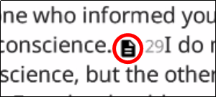 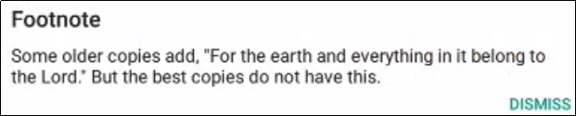
2. It’s not possible to copy/paste the footnote text.
3. You may need to write down the translation because you can’t have the original footnote open and type into the footnote translation at the same time.
4. Open the translated chunk for editing.  
   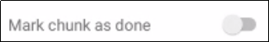 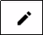
5. Tap at the place where you want to add the footnote.  
   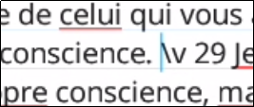
6. Tap the Add Footnote icon.  
   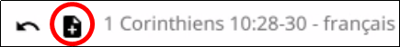
7. Translate the footnote text into the “Add Footnote” pop-up and tap OK.  
   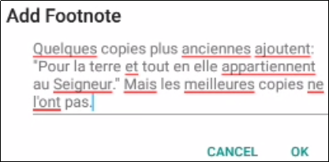
8. The footnote icon now appears inline. Tap the check mark to save the changes.  
   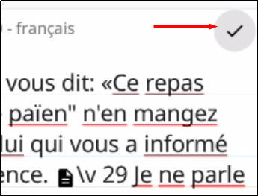

To edit or delete a translated footnote:

1. Ensure the chunk is **not** marked done and that you are **not** in Edit mode.
2. Tap the footnote.  
   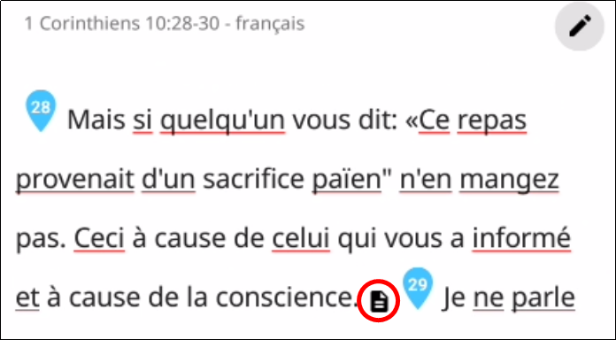
3. Tap **DELETE** to delete it or **EDIT** to edit it.  
   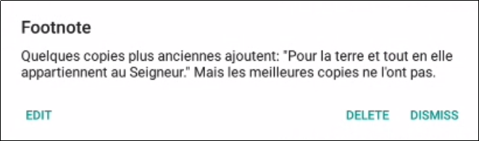
4. When finished, mark chunk as done.

## Upload/Export Your Work

When you work in translationStudio, your text is saved every five minutes to your device. Your work is not saved to Door43 until you upload it.

While you are in a project in translationStudio, tap the 3-dot icon  to access the options menu. Select **Upload/Export** (the upward arrow icon ).   


There are six Upload/Export options.  
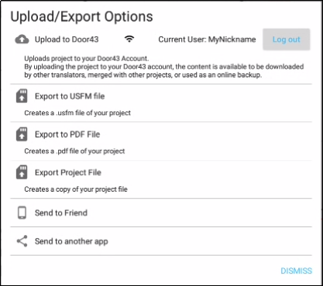

* Tap **Upload to Door43** to copy your work to the online Door43 server, making it available to other translators and creating an online backup. You can upload to Door43 only if you have an internet connection and are logged in to a Door43 account. A pop-up message appears after a successful upload. This pop-up message includes the repository that the translation is in on the Door43 server. Tap the link to view the repository. The translation has been uploaded to the server. There is a documentation process that takes place for public publishing. See Publish Contentfor more information.
* Tap **Export to USFM or SD Card** to create a USFM (paratext) file. You can specify where to store the USFM file. Tap **Confirm** to start the export. You can then edit the file name or leave it as is.  
   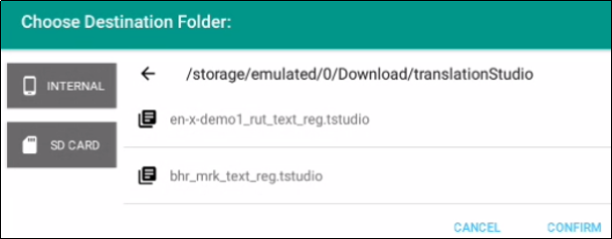   
    
    
  A pop-up message appears after a successful download to show the location of your file.   
  Tap **Dismiss** to dismiss the message once you make note of the file location.  
  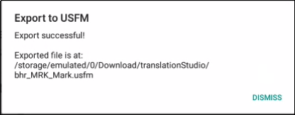
* Tap **Export to PDF** to create a PDF file of your work. You have the option to include incomplete chunks or not. When you have decided, tap **Print**.   
  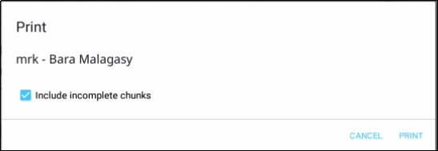  
    
  Choose your destination folder and tap **Confirm**.   
  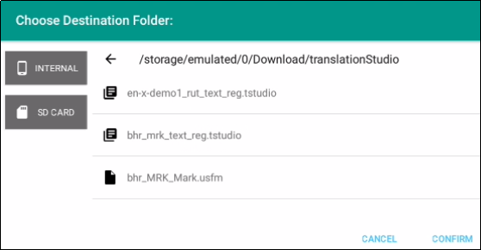   
    
  You can edit the file name or leave it as is, and then tap **OK**, or tap **Cancel** to cancel the export.  
  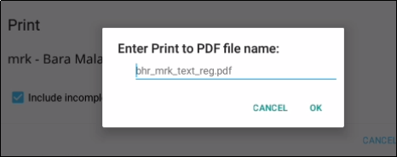  
    
  Choose where to share the PDF. A processing window appears (and may quickly disappear). Tap **Dismiss** to go back to the Upload/Export options.  
  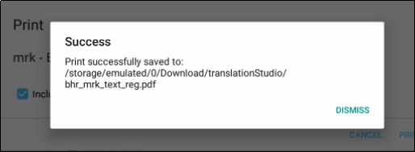
* Tap **Export Project File** to create a copy of the entire project file. The steps are the same as exporting to a PDF above.
* Tap **Send to Friend** to export the file to another device.
  + You are asked to specify a name for your device. Enter a name and then tap **Confirm**.  
    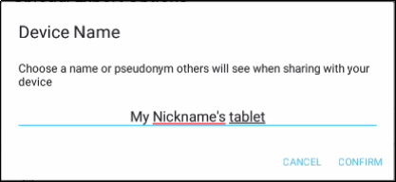
  + A window then displays all available devices. Tap the one where you wish to export the file.   
    If no devices are available, tap **Cancel**.  
    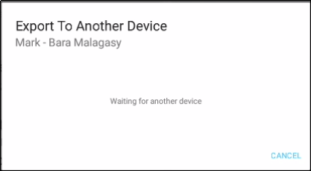
  + Close the window when told that the export process is complete.
* Tap **Send to another app** to send the file to other apps on your device, such as email. Tap the desired app:
  + Tap **Save to Drive** to send your work to a Google Drive that has been created before. This requires an Internet connection.
  + Tap **Nearby Share** or **Android Beam** to send your work to a nearby device that has translationStudio installed on it. The app will attempt to locate the device.
  + Tap **Bluetooth** to send your work to a nearby device that is paired to yours through Bluetooth. If the app continues searching for more than a minute, exit the screen and verify that the devices are paired through Bluetooth.
  + ****Tap **Gmail** to send your work to an email account. This requires an Internet connection.  
    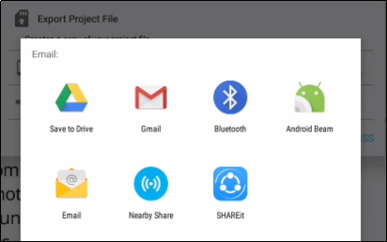

The app opens and enables you to send the project file as an attachment.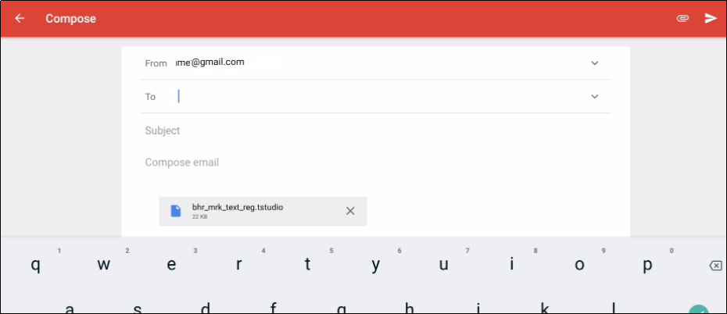

## Recovering Deleted Translation Text

If you accidentally delete a large amount of work, contact [help@door43.org](mailto:help@door43.org).

## Publish Content

Self-Publishing

When you upload your work to Door43 it is automatically available online under your user account. This is referred to as self-publishing. You can upload to Door43 as often as you wish to create a backup of your work. (See Backup and Share Your Work.)

You can access a web version of your project at http://door43.org/u/*user_name*/*project_name* (where *user_name* is your user name and *project_name* is your translation project). The translationStudio app gives you the correct link when you upload. You can also browse all works on [http://door43.org](http://door43.org/).

From your Door43 project page you can:

* See the web version of your project with default formatting
* Download documents of your project (like a PDF)
* Get the links to the source files (USFM or Markdown) for your project
* Interact with others about your project

### Source Text Publishing

Source text publishing is required for all Gateway Languages so that they can be used as source texts by Other Languages. Note that **this process applies only to Gateway Languages**. There are several steps to the process of publishing your work.

#### Prerequisites

Before a Gateway Language translation can become a source text, the following prerequisites must all be met:

* Whole Resource - The whole resource must be translated and checked to the required level. Parts of resources (e.g. half of the Open Bible Stories, only a few chapters of a book of the Bible) cannot be published.
* Checking - A translation must have reached the appropriate checking level. For Bible translations, this is checking level 3: <https://live.door43.org/u/Door43/en_ta/eccd2b1a6f/04-checking.html#level3>.
* On Door43 - Door43 must have the version that will be published. If the work was done on multiple devices, then it may need to be merged together. Get the help of a Content Tech to make merging easier (either email help@door43.org or use the #content-techs channel on Slack).
* Agreements - Everyone involved in the translation and checking must have agreed to the Statement of Faith, the Translation Guidelines, and the Open License. This can be done either by creating Door43 accounts or by physically signing the documents and digitizing them (scanning or photos). See [http://ufw.io/forms](http://ufw.io/forms%20) for downloadable agreement forms.

You can use translationStudio to ensure that the project is complete and that all contributors are listed. You can perform project review by completing the following steps to publish your work:

1. In translationStudio, load your project.
2. Tap the **3-dot icon**  to access the options menu.
3. Tap **Project Review** (the double check marks icon).
   * Tap the **Project** tab -- Review sections of the book for final review.
     1. We suggest that you review any chunk that has a review button. These are chunks that are not marked done.
     2. Tap the Review button to finish translating, or set the verse markers and then slide the 'done' toggle.
   * Tap the **Contributors** tab -- This is where you enter who translated the work. Remember that the names will be publicly available.
     1. ****Tap **Add Contributor**.  
        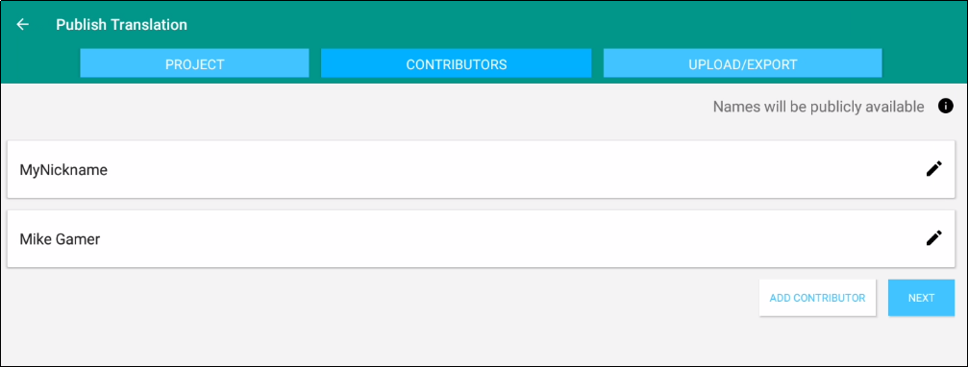
     2. In the Add Contributor pop-up window:
   * Tap the **Name or Pseudonym** line and enter the contributor’s name or pseudonym.
   * Tap the check box to indicate that this person has agreed to the terms of use.
   * ****Tap **Save** to add the translator.  
     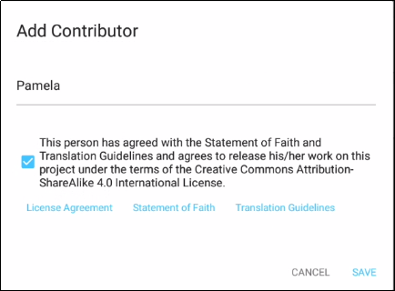
     1. Repeat steps 1 and 2 above for each contributor you want to add.
     2. When you have finished adding contributors, tap **Next** to continue, or tap the **Upload/Export** tab.
   * When you either tap Next in the step above, or tap the Upload/Export tab, you are presented with Upload/Export Options.
     1. Select **Upload to Door43** (requires an Internet connection).
     2. A pop-up message appears after a successful upload. This pop-up message includes the repository that the translation is in on the Door43 server.
     3. Tap the link to view the repository.

#### Source Text Request Form

Once you have the prerequisites, you may fill out the source text request form at <http://ufw.io/pub/>. A few notes about the form:

* You must have a Door43 account to create a request.
* You must include the names or pseudonyms of everyone involved. You must also include their Door43 usernames if you are not attaching signed license agreements for them.
* Note that the information you enter will be public and will become a part of the front matter of the source text.

After you submit the form, you will be contacted if anything is missing. Once the request has been approved, it will go into the publishing queue where a developer will work to make the translation a source text. You may also be contacted by the developer if there are any issues encountered during the publishing process. You will be notified when the process is completed and you may review a PDF of the work.

#### Questions Regarding the Request to Publish Form and Process

##### What Happens After Text is Approved?

When the Request to Publish is approved, the text is made available on [unfoldingword.org](https://unfoldingword.org/) for online viewing, as a downloadable, print-ready PDF, and it appears in the unfoldingWord app.

##### Can Text Be Changed After Level 3 Checking?

Approved text can always be modified in translationStudio even after all checking levels are completed, HOWEVER if you or another user were to submit a Request to Publish for text that has already completed Level 3 checking, there would be questions regarding the reason for overwriting the previously published and checked materials. The approver will look to see who contributed to the change and may contact the requestor and others involved with the translation of the text in question to ensure the changes are valid.

##### Must All Contributors Be Named?

Due to copyright laws (and these exist no matter what country you are in and no matter what people tell you about laws in that country), you must list every contributor as they prefer to be mentioned.  Normally this is the person's name or pseudonym.

## Settings Window

To open the settings window, tap the 3-dot icon  at the bottom left (or right) of the screen and tap **Settings** on the menu.

Tap the **Back Arrow** at the top left of the screen to exit the settings window.

The Settings window allows for personalization of the program. It also displays useful information. Settings are divided into four categories:

1. General
2. Server
3. Legal
4. Advanced

### General Settings

****Tap **General** to view or change general settings.  
  
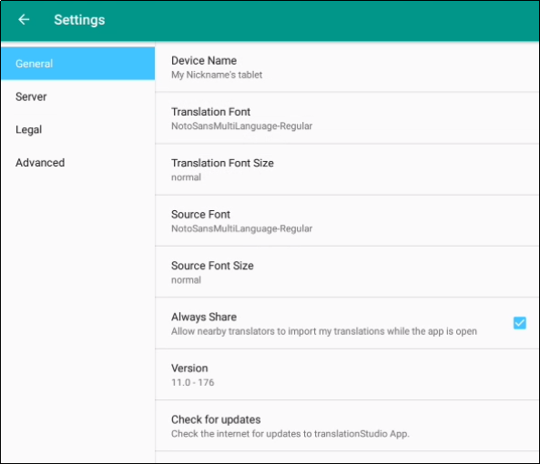

The General settings are as follows:

1. **Device name**
   1. Naming the tablet is helpful when sharing with a friend. See Backup and Share Your Work for more information.
   2. Tap **Device name** to name the tablet. A pop-up window opens where you can enter a name for your tablet.
   3. ****Tap **OK** to save the name.  
      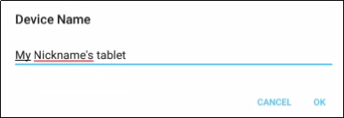
2. **Translation** **Font**
   1. The name of the chosen font is displayed. Tap **Translation Font** to change the displayed font in the text.
   2. ****A pop-up window shows the available fonts. Scroll through the names of the fonts and tap the name to select the desired font.  
        
      ****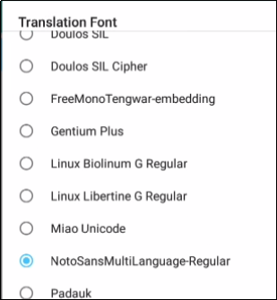
3. **Translation** **Font Size**
   1. The size of the chosen font is displayed. Tap **Translation Font size** to change the displayed font size in the text.
   2. ****A pop-up window shows the available sizes. Tap the desired size to select it. When you have selected a font, the pop-up window disappears.  
      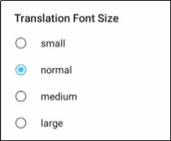
4. **Source Font**
   1. The name of the chosen font is displayed.
   2. Tap **Source Font** to change the displayed font in the source.
   3. A pop-up window shows the available fonts. Scroll through the names of the fonts and tap the name to select the desired font. When you have selected a font, the pop-up window disappears.
5. **Source Font Size**
   1. The size of the chosen font is displayed.
   2. Tap **Source Font Size** to change the displayed font size in the text.
   3. A pop-up window shows the available sizes. Tap the desired size to select it. When you have selected a font size, the pop-up window disappears.
6. **Always Share**
   1. Tap in the empty square if you want the program to allow nearby translators to import your translations while the app is open.
   2. A blue square with a white check mark means that the option has already been chosen.
7. **Version**: The version of the translationStudio program is displayed.
8. **Check for updates:** Tap to check for updates to translationStudio. This uses an internet connection.

### Server Settings

Keep the settings for the server as determined by the program. There is no need to edit any of the settings unless directed by an unfoldingWord support technician.

### Legal Settings

Tap **Legal** to view important legal information.   
  
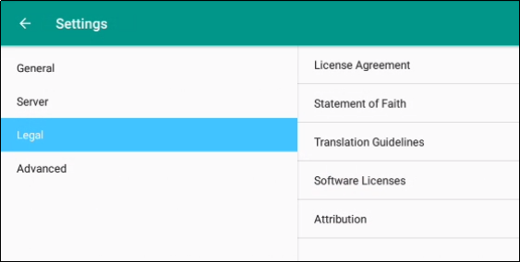

* **License Agreement** - read what you are permitted to do with the content in the program and the content that you create.
* **Statement of Faith** - you, the user of the program, agreed to this the first time the program was started. Read this to review what the Essentials Beliefs are.
* **Translation Guidelines** - read this document to learn about the guidelines that can help the translator clearly, accurately and naturally translate the text.
* **Software Licenses** - this file contains all the licenses for the various softwares that are used to create the translationStudio program.
* **Attribution** - read this document to learn about the restrictions of using the derivative works and name branding.

### **Advanced Settings**

**Check Hardware Requirements**: Specify whether to check for suggested hardware when the app starts.

**Backup Interval**The program sets the backup to occur every 5 minutes. This can be changed by the end user.

* Tap the words 'Backup Interval' to open the option screen.
* Tap the words to change the interval to '1 Minute', '5 Minutes', '10 Minutes' or to 'Disable Backup.' It is NOT recommended to disable the backup.

### Logging Level and Developer Tools

The settings in these areas are set by the program. You should not change these settings unless directed to do so by a translationStudio technician.

## Find My Language

If you do not see your language in the list of target languages, first try alternate spellings, dialect names, and any variant names for your language. If you still can't find it, you can request that your language be added.

The best way to submit a request is to send an email to help@door43.org. Another method is to use the Feedback option from the options menu to submit a Bug Report. In either case, please provide as much information as you can about the language, such as the local name of the language, any other names it is known by, approximate number of speakers, where it is spoken, any similar languages, any published works in that language, etc.

Use **Feedback** in the 3-dot options menu to request a new language:

1. From any screen in translationStudio, tap the 3-dot icon  on the left or bottom.
2. In the list of options, tap **Feedback**.
3. The **Feedback** screen opens. Type the name of the language you would like added to translationStudio. Provide the location pf the speakers and other names the language is known by. If you used a language that is already in the APP, tell which language you used.
4. ****Tap **Confirm** to send your request.  
   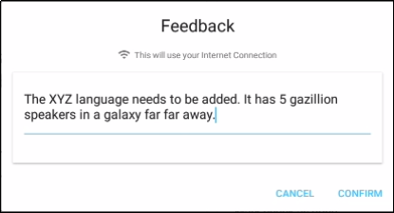

Note that even after requesting a new language, certain approvals are required before it will be added to translationStudio. Until your language is added to the APP, use *English Demo1* or *English Demo2*. You will need to use the Feedback option from the options menu to send a comment stating that you used another language for your own. Once your translation has been received, the tS workers will put it in the correct language. Your translation will then show in your language.

## Backup and Share Your Work

You can share your work with another program, send it to another device, or put it on an SD card. When your work is on a storage card, you can put it on a computer or device that has the translationStudio app.

**Note:**You can move or share only the changes that have been made on the device you are using to perform this function. In these instructions, "your work" means any changes made on this device.

To share, move, or store your work, see Upload/Export Your Work.

## MAST Core Concepts

**What is MAST?**

MAST stands for **M**obilized **A**ssistance **S**upporting **T**ranslation

MAST is a program for the rapid drafting of Scripture that is designed to be easy to learn and follow. The steps are designed to work together in sequence so that, when a translator follows them carefully, the outcome will be a draft of Scripture text that speaks naturally in the target language, and has been checked by several people to make sure that it communicates everything that the source text communicated.

**Methodology Steps in MAST**

MAST methodology is comprised of eight steps. The first four describe the Drafting Steps and the last four describe the Checking Steps.

**Drafting Steps**

1. **Consume** - Take in the source text, usually one chapter at a time for scripture translation. For a written translation, the translator would read the chapter, and for an oral translation the translator would listen to the chapter.
2. **Verbalize** - Express what you just consumed to someone else. Tell this other person what the chapter is about. It is best if you can do this in the target language. This should not be a detailed discussion of the text in exegetical form. This should largely focus on the expression of the main points of the chapter.
3. **Chunk** - Group the text of the chapter into sections. These sentences in each section should fit together because of a shared topic, theme, or chain of logic. The sections should be bigger than sentences or verses, often 2, 3, or 4 verses at a time. If you are translating in translationStudio from the ULB and UDB texts, you do not need to do this step because the chunking has been done for you. But if you would like to make different chunks than the ULB and UDB have, then go ahead and do so.
4. **Blind Draft** - Set aside the source text and draft the chunk as well as you can without looking back at the text. Write everything that you remember about that chunk. Do not look back at the source text for this chunk until you begin the editing steps. Continue doing this with each chunk of the chapter before moving to the checking steps. (This step is for translating OL Bibles, not for translating the GL translation tools. In order to translate the GL translation tools such as the ULB, UDB, and Notes, you must have the source available to look at as you translate.)

**Checking Steps**

1. **Self edit** - The translator can now examine their newly drafted scripture chunks and compare them to the source text(s). Any error can be edited and corrected at this point, The key focus question at this step is, "What did I miss?" Anything that was missed in blind drafting should be added into the translation now, in the place where it is most natural in the target language.
2. **Peer edit** - When the translator has finished the self-edit step for the whole chapter, they should trade it for a chapter that another translator has finished self-editing. The translators will examine each other's chapter, looking for anything that seems unnatural as well as anything that seems to be inaccurate. When they find a problem, they should mark it and then discuss the problems and fix them together.
3. **Keyword Check** - a facilitator, working with the translator, should examine each new drafted chapter for all key words in two steps:
   * A. The facilitator should ask if each key word is present in the newly translated scripture. If it is not, then it either needs to be added or there needs to be a good reason why it is not, such as the meaning being communicated by a different word or words.
   * B. The facilitator should ask the translator to provide a definition of each key word in the text and compare it to an already developed list of contextual definitions. These definitions should match. If they do not, the translation team needs to discuss which word is the best to use for the key term in this context.
4. **Verse-by-Verse Check** - a facilitator should examine each verse of the newly translated chapter and compare it to the source text to make sure that it accurately communicates the same message as the source and to verify with the translator that the verses flow naturally in the target language.

## Choosing What to Translate

### What Should I Translate First?

At some point, the translation team will have to figure out what they should translate first, or, if they have already done some translation, what they should translate next. There are several factors that need to be considered:

* What does the church want to be translated?
* How experienced is the translation team?
* How much Biblical content has been translated into this language?

The answers to these questions are important. But remember this:

**Translation is a skill that grows with experience.**

Because translation is a skill that grows, it is wise to start translating content that is less complicated so that the translators can learn the skill while translating something simple.

***Translation Difficulty***

Wycliffe Bible Translators have rated the difficulty of translating the different books of the Bible. In their rating system, the most complicated books to translate receive a level 5 difficulty. The easiest books to translate are a level 1.

In general, books that have more abstract, poetic, and theologically loaded terms and ideas are more difficult to translate. Books that are more narrative and concrete are generally easier to translate.

**Difficulty Level 5 (Most Difficult to Translate)**

* + Job, Psalms, Isaiah, Jeremiah, Ezekiel
* New Testament
  + Romans, Galatians, Ephesians, Philippians, Colossians, Hebrews

**Difficulty Level 4**

* Old Testament
  + Leviticus, Proverbs, Ecclesiastes, Song of Solomon, Lamentations, Daniel, Hosea, Joel, Amos, Obadiah, Micah, Nahum, Habakkuk, Zephaniah, Haggai, Zechariah, Malachi
* New Testament
  + John, 1-2 Corinthians, 1-2 Thessalonians, 1-2 Peter, 1 John, Jude

**Difficulty Level 3**

* Old Testament
  + Genesis, Exodus, Numbers, Deuteronomy
* New Testament
  + Matthew, Mark, Luke, Acts, 1-2 Timothy, Titus, Philemon, James, 2-3 John, Revelation

**Difficulty Level 2**

* Old Testament
  + Joshua, Judges, Ruth, 1-2 Samuel, 1-2 Kings, 1-2 Chronicles, Ezra, Nehemiah, Esther, Jonah
* New Testament
  + *none*

**Difficulty Level 1 (Easiest to Translate)**

* *none*

**Open Bible Stories**

Though Open Bible Stories was not assessed according to this rating system, it should fall under Difficulty Level 1. We recommend that you begin by translating Open Bible Stories. There are many good reasons to start by translating Open Bible Stories:

* Open Bible Stories was designed to be easily translated.
  + It is largely narrative.
  + Many difficult phrases and words have been simplified.
  + It has many pictures to help the translator understand the text.
* Open Bible Stories is much shorter than the Bible or even the New Testament, so it can be quickly completed and distributed to the Church.
* Since it is not Scripture, Open Bible Stories removes the fear that many translators have of translating the Word of God.
* Translating Open Bible Stories before translating the Bible gives the translators experience and training in translation, so that when they translate the.

Bible, they will do it well. By translating Open Bible Stories, the translation team will gain:

* Experience in creating a translation and checking team
* Experience in doing the translation and checking process
* Experience in using the Door43 translation tools
* Experience in resolving translation conflicts
* Experience in getting church and community participation
* Experience in publishing and distributing content
* Open Bible Stories is a great tool to teach the church, evangelize the lost, and train the translators in what the Bible is all about.

You can work your way through the Stories in whatever order that you want, but we have found that Story #31 (see <http://ufw.io/en-obs-31>) is a good first story to translate since it is short and easy to understand.

***Conclusion***

Ultimately, the church needs to decide what they want to translate, and in what order. But because translation is a skill that improves with use, and because the translation and checking teams can learn so much about translating the Bible by translating Open Bible Stories, and because of the immense value that the translated Open Bible Stories gives to the local church, we highly recommend starting your translation project with Open Bible Stories.

After translating Open Bible Stories, the church will need to decide if it would be more beneficial to start with how everything began (Genesis, Exodus) or with Jesus (New Testament gospels). In either case, we recommend starting Bible translation with some of the Difficulty Level 2 and 3 books (like Genesis, Ruth, and Mark). Finally, after the translation team has a lot of experience, then they can start translating Difficulty Level 4 and 5 books (like John, Hebrews, and Psalms). If the translation team follows this schedule, they will make better translations with far fewer mistakes.

## Updating Program Elements

Select Update from the Options menu on the home page to see the options for updating program elements. You must be connected to the internet to exercise any of the update options.  
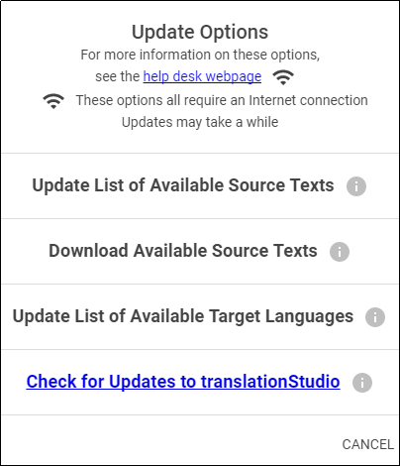

The options are:

* Update List of Available Source Texts
* Download Available Source Texts
* Update List of Available Target Languages
* Check for Updates to translationStudio
* Updating Source Text Lists

### Updating List of Available Source Texts

To update the source text lists, select Update List of Available Source Texts from the Update menu.   
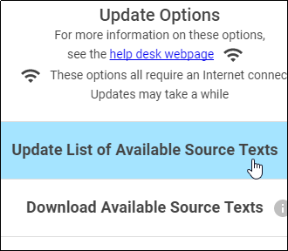

This process updates ONLY the list of the available source texts, not the texts themselves. The purpose for downloading only the list of source texts is to reduce the number of files that would need to be downloaded. You will need to download a source text before using it.

Updating the list takes several minutes, so you need to wait for the process to complete.  
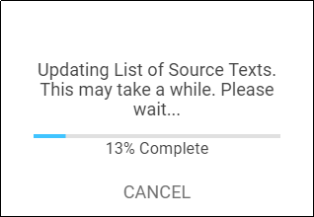

**Note**: You may receive a notice that the process is not complete; sometimes this notice is not accurate.

When the process is complete, the program notifies you of the number of new source texts that you can download. You may close the window.  
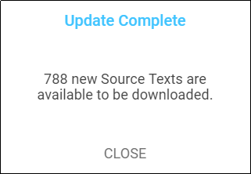

The program now presents you with choices to download selected source texts. If you don’t want to download now, tap Home in the breadcrumbs at the top of the page. If you do wish to download one or more source texts, the process is shown below.

### Downloading Available Source Texts

To download new source texts, tap Download Available Source Texts from the Update menu.  
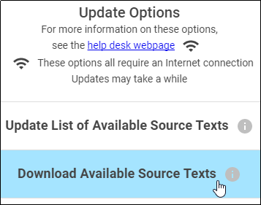

You have a choice to look at the source text lists in one of two ways:  


1. **By Language** – this choice enables you to download multiple books at once for a single language. If you choose to view by language and select a language, only the books that are available for that language are shown. Other books may become available as more source texts get translated and checked.
2. Type the language name in the search box or scroll to the desired language.  
   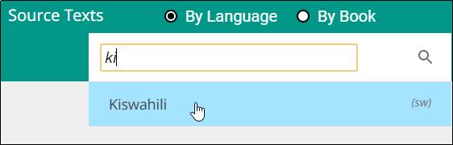
3. Tap the language to select it (if you tap a language by mistake, tap the back arrow next to the language to return to the language list.)
4. On the Choose Category list, tap to select a category. Some languages have more or fewer categories, depending on what source texts are available.  
   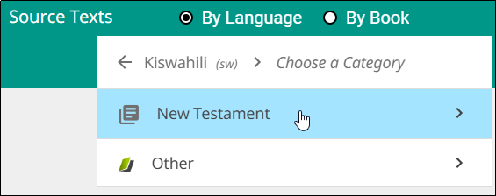
5. Tap the check box next to the source text(s) you wish to download, and then tap Download.  
   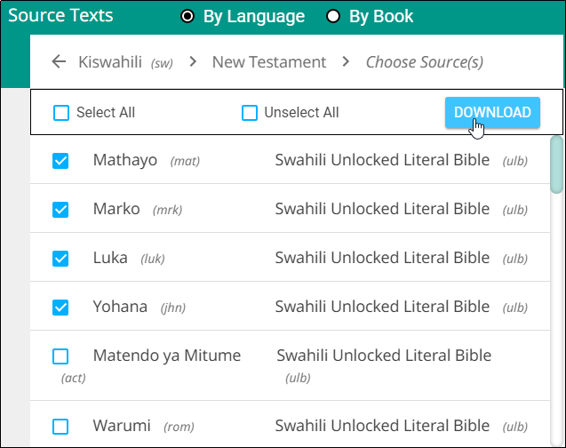
6. The selected text(s) download (this may take a few minutes) and then you should receive a success message. Tap Close.
7. The downloaded texts have a green check mark next to the name on the Source list.

Note: You may receive an unsuccessful message. One or more choices have a red x next to the name. This source text was not downloaded. You may try again to download the texts that were not successfully downloaded.



1. **By Book** – this choice enables you to download multiple languages at once for a single book. If you choose to view by book, only the languages for which that book is available are shown. Other books may become available as more source texts get translated and checked.
2. Tap to select a category. The possible categories are:  
   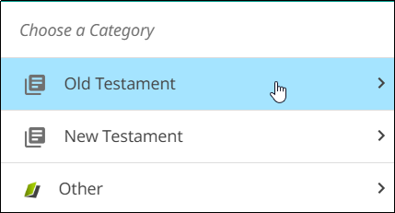 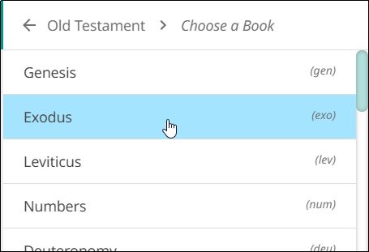
   1. Old Testament: Opens a list of Old Testament books
   2. New Testament: Opens a list of New Testament books
   3. Other
      1. Open Bible Stories
      2. translationWords
      3. translationWords OBS
3. Once you have selected a category, a list of available source texts opens. Select one or more source texts and tap Download.  
   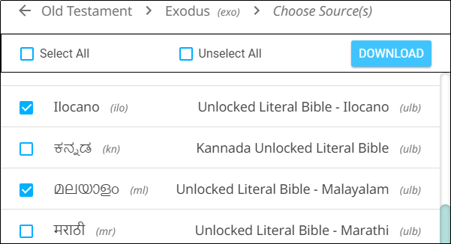
4. The selected text(s) download (this may take a few minutes) and then you should receive a success message. Tap Close.
5. The downloaded texts have a green check mark next to the name on the Source list.

Note: You may receive an unsuccessful message. One or more choices have a red x next to the name. This source text was not downloaded. You may try again to download the texts that were not successfully downloaded.

### Updating List of Available Target Languages

Tap Update List of Available Source Texts from the Update menu to update the list of all the target languages available in the program.  
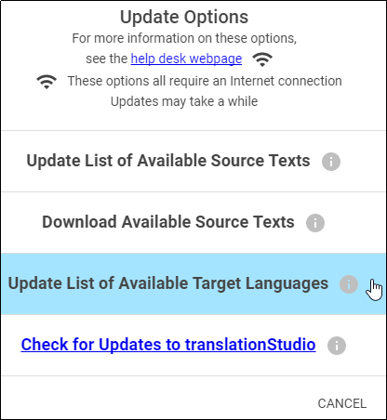

A progress window opens.  
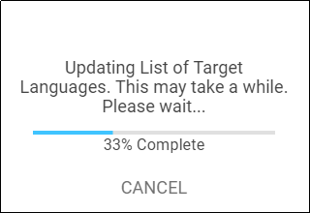

At the end of the process a message shows how many new target languages were added. Tap CLOSE to return to the Home screen.  
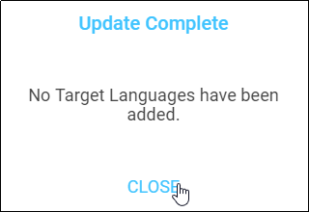

### Checking for Updates to translationStudio

Tap Check for Updates to translationStudio from the Update menu to download any available updates to the translationStudio program.  
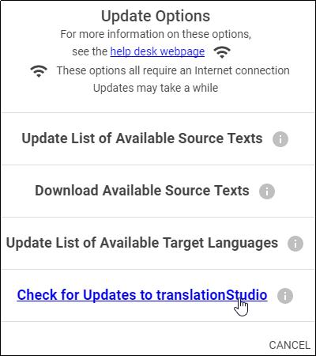

Unless you have a very old version of translationStudio, there probably are no updates available.  
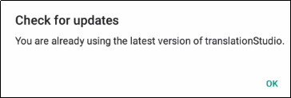

## Find the Resources (Helps) in translationStudio

All of the translationNotes, translationWords and translationQuestions are included in the translationStudio mobile app.

Tap the **Check** icon  that looks like three vertical lines.

Swipe from the right to the left side, or tap in the right margin, to show the resources for a chunk.   


The Resources pane is divided into three tabs: Notes, Words, and Questions.   


If there are no existing resources for a particular chunk, the resources pane is blank. If there are no resources of one of the types, then that tab does not exist on the resources pane. For example, if there are no Words for a chunk, then you would see only the Notes and Questions tabs on the Resources pane for that chunk.

* Tap the **Notes** tab for the translationNotes.

 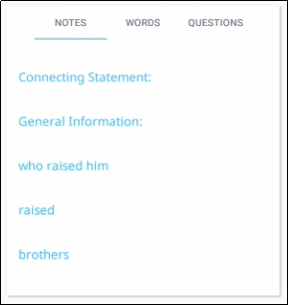  
The words or phrases are listed as they appear in the story or in the ULB. Tap the phrase for help in understanding how to translate into the target language. See <https://dw.door43.org/en/ta/vol1/translate/resources_types> for more information.

* Tap the **Words** tab for the translationWords.

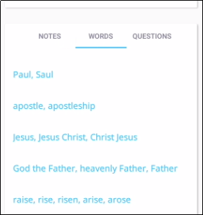   
The words are listed as they appear in the story or in the ULB. Tap the word or phrase for help in understanding how to translate the word into the target language.

* Tap the **Questions** tab for the translationQuestions.   
  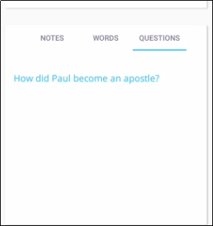  
  The questions are about information as it appears in the story on in the ULB. Read the question and answer it according to the translated text. Tap the question for the expected answer. If the given answer and the expected answer are the same then the translation might be clear and accurate.

When you are done with the translationHelps, swipe from left to right to make the pane disappear.

## 